EE559-Homework#4-Lei Lei

1.(a) Final (augmented) weight vectors:

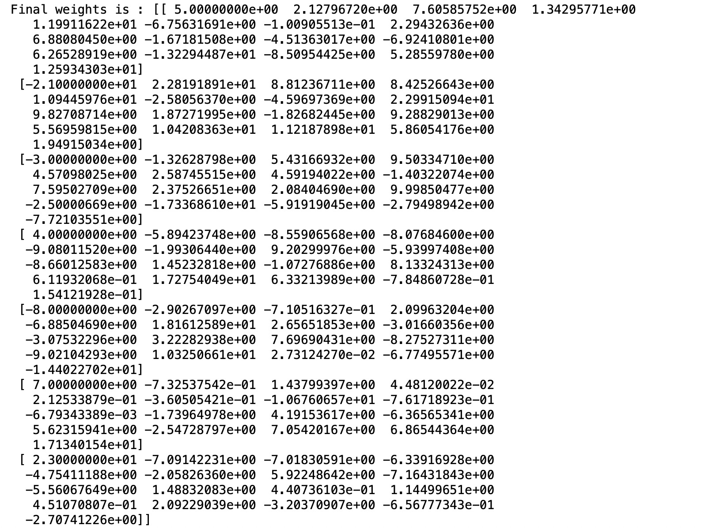

Their magnitudes:



Accuracy and confusion matrix C:

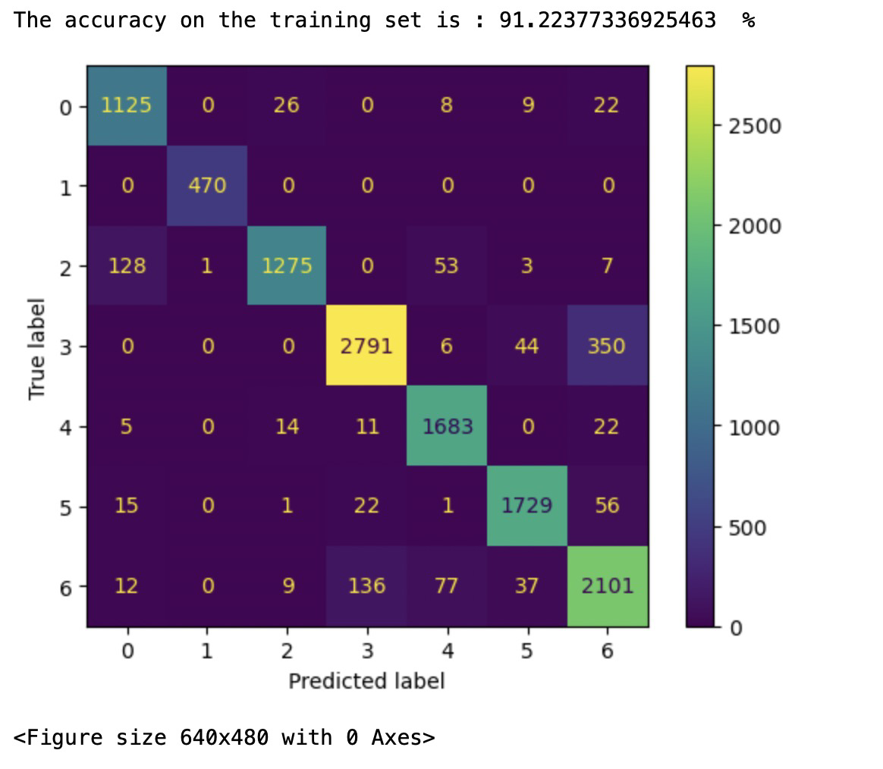

testing

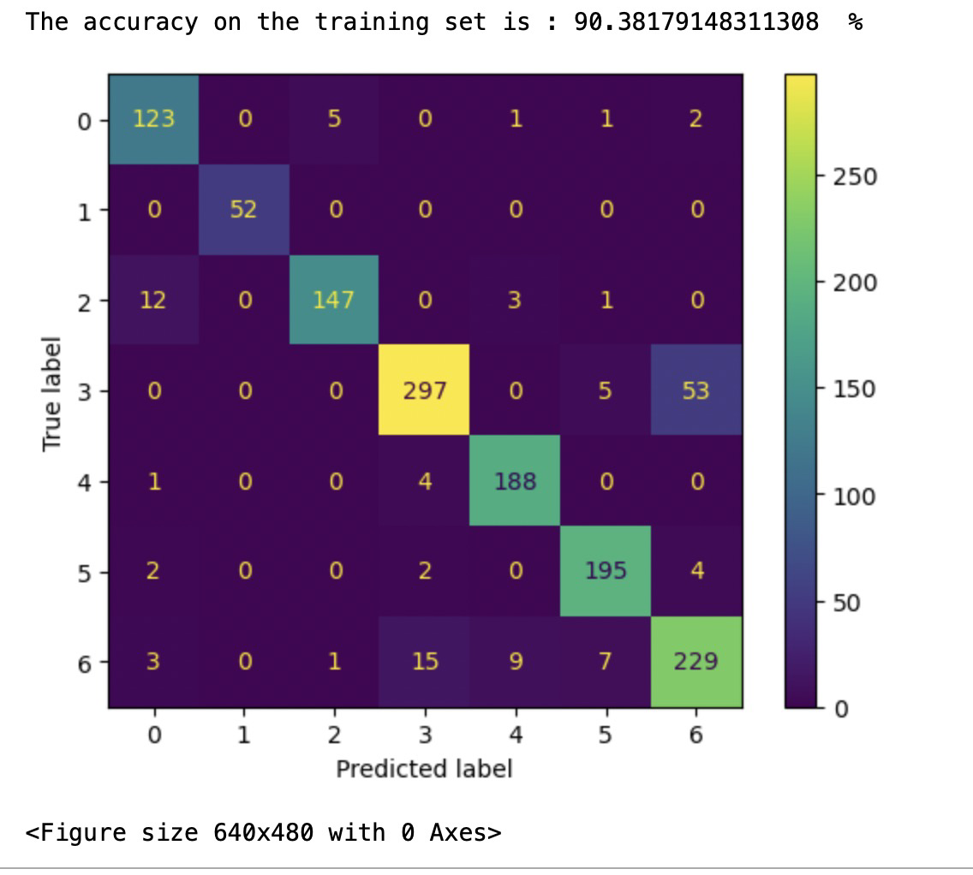

(b) 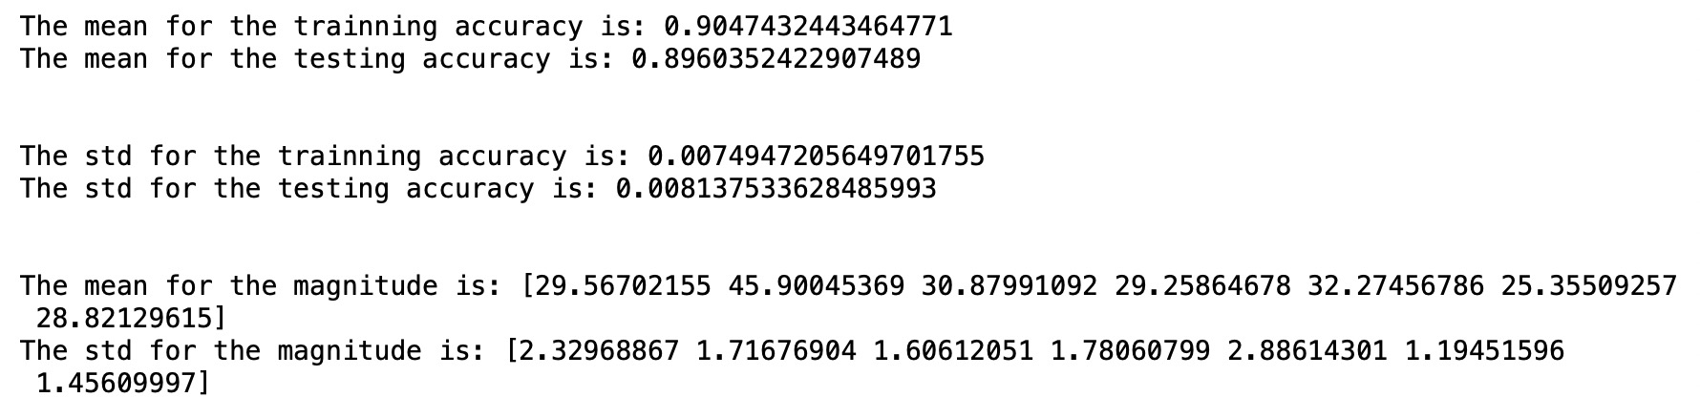

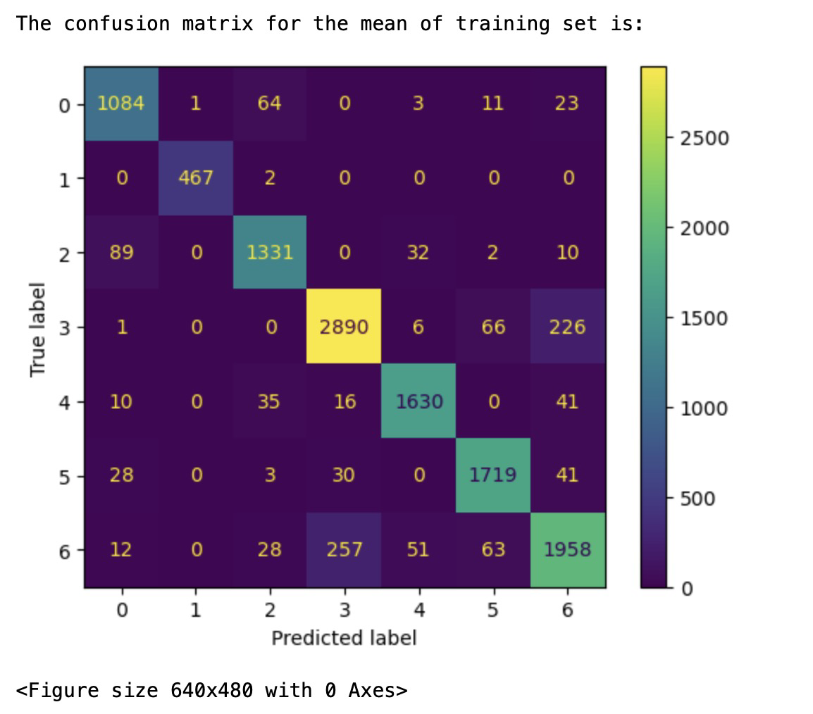

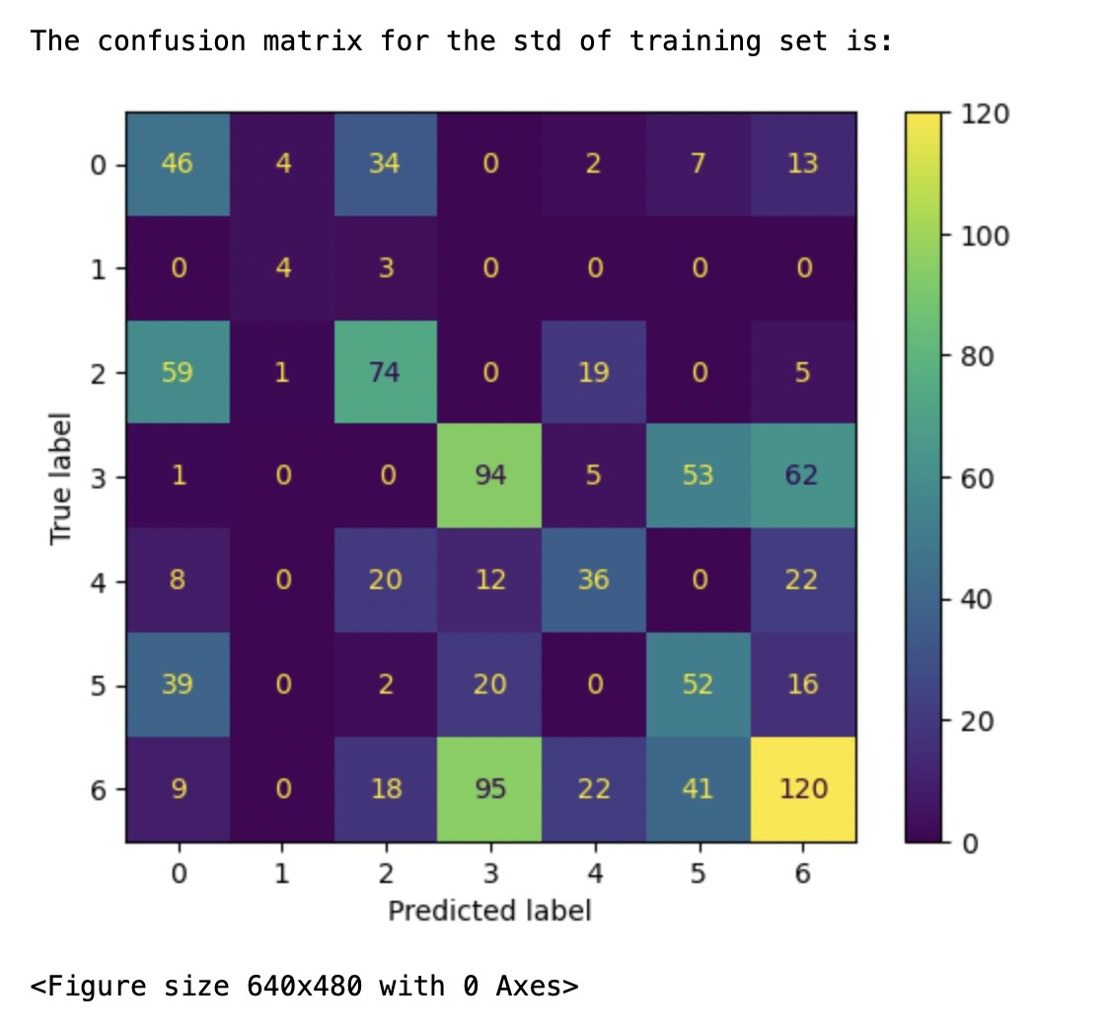

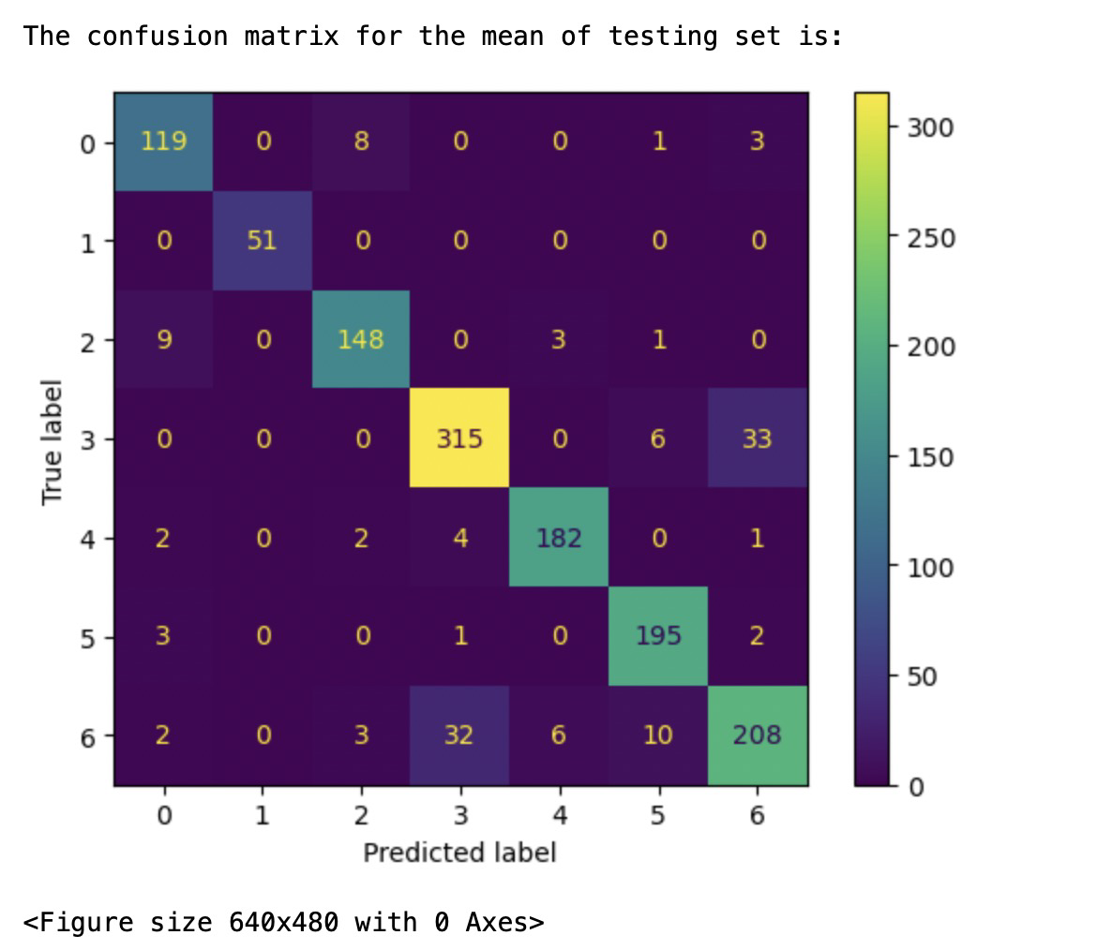

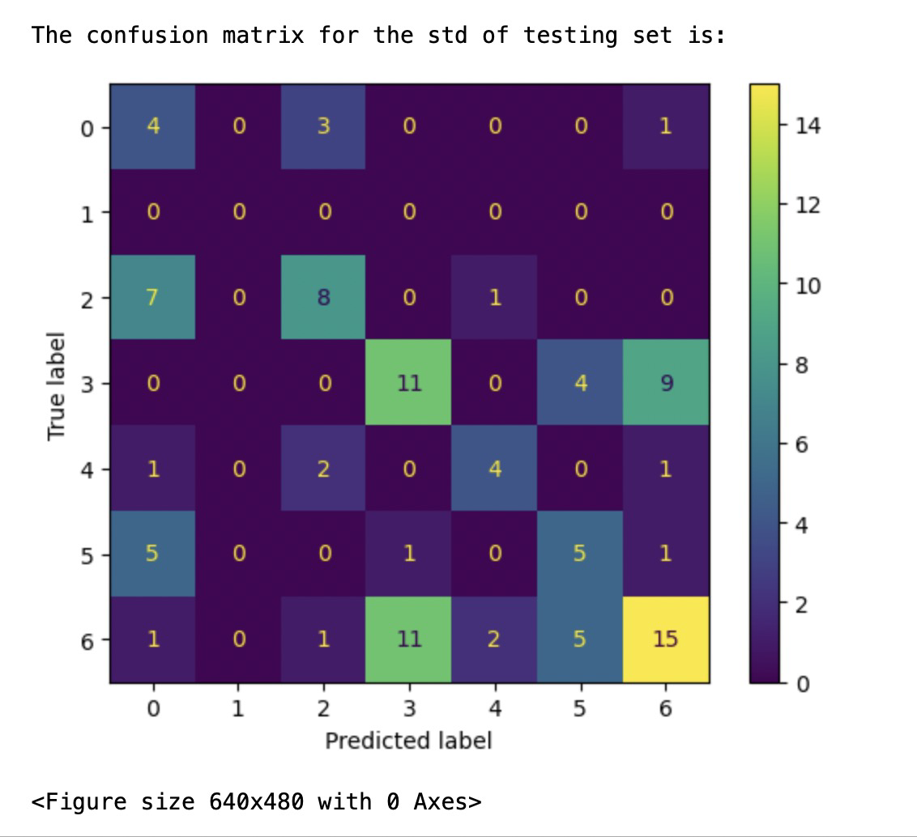

2.(a) OvR classifier

Class 1:

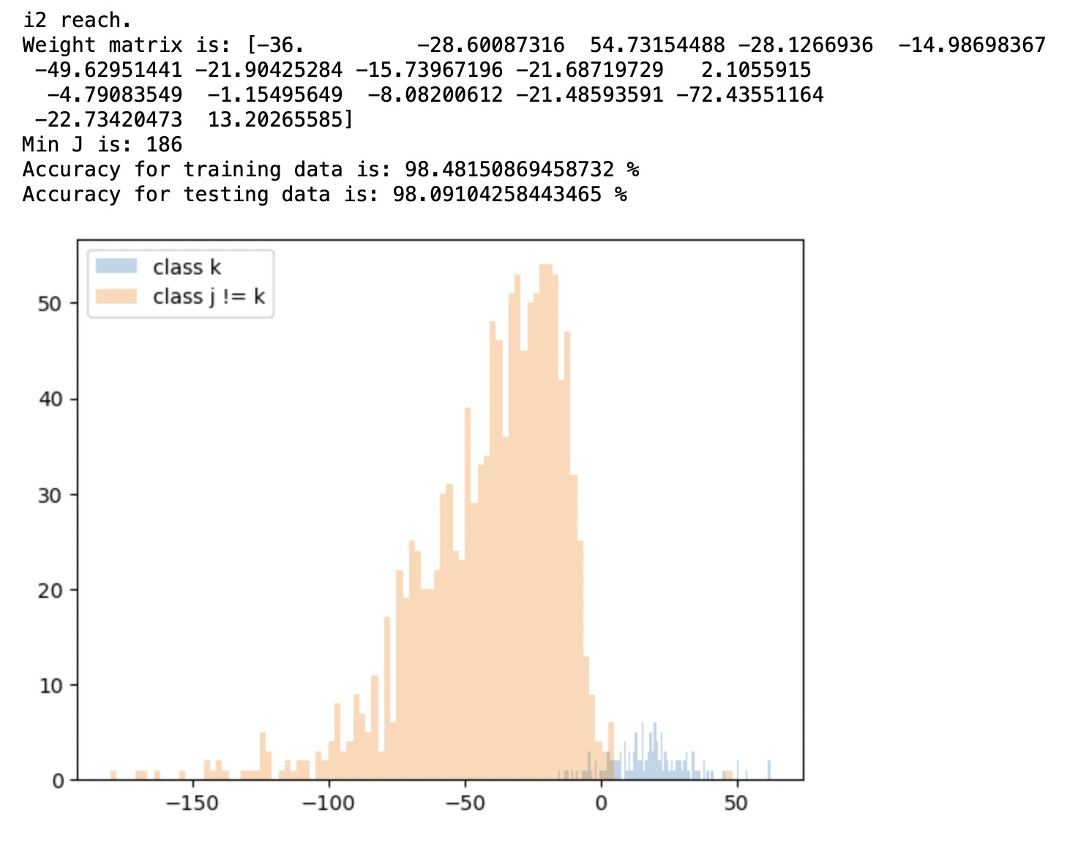

Class 2:

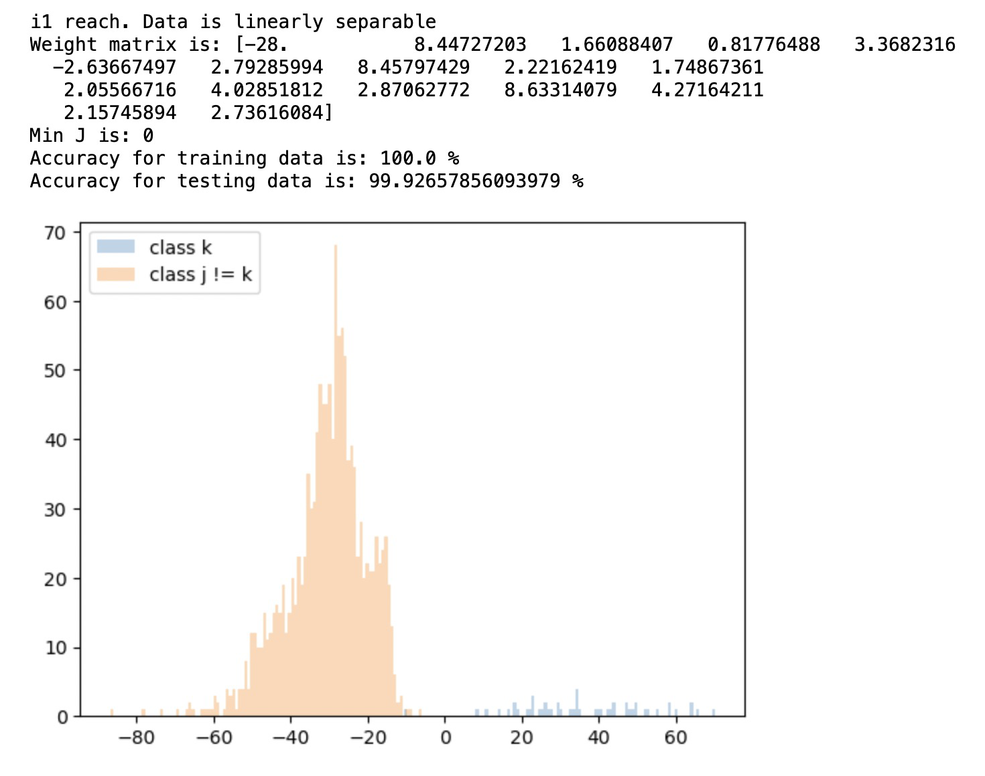

Class 3:

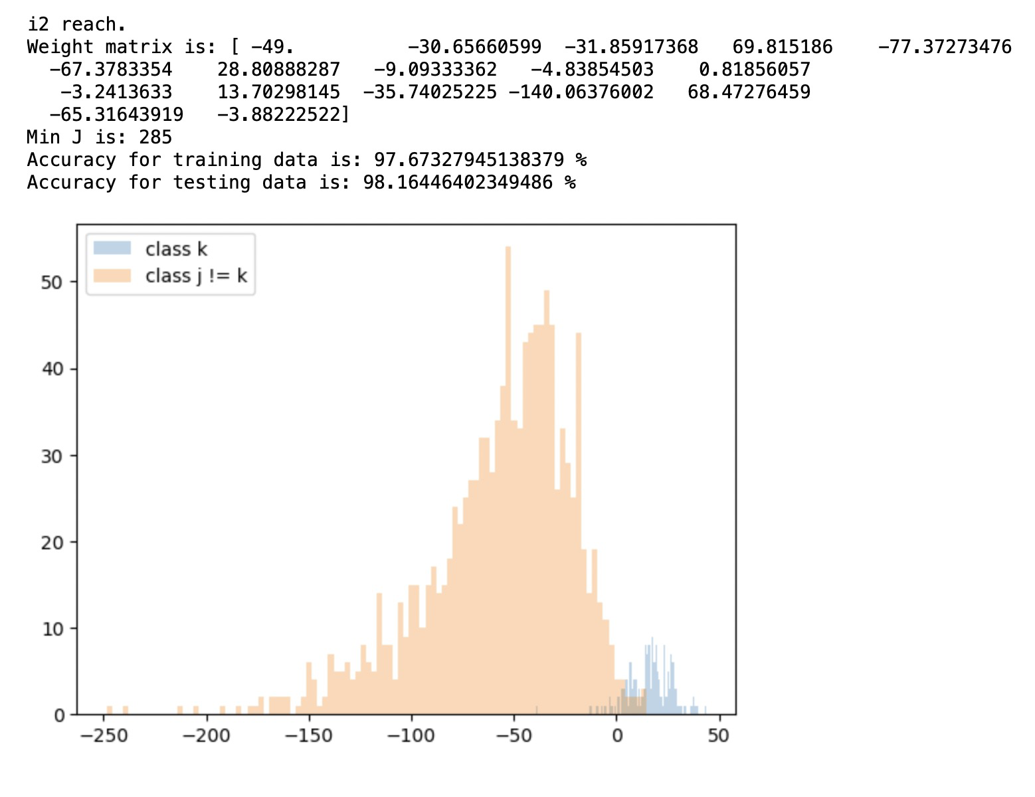

Class 4:

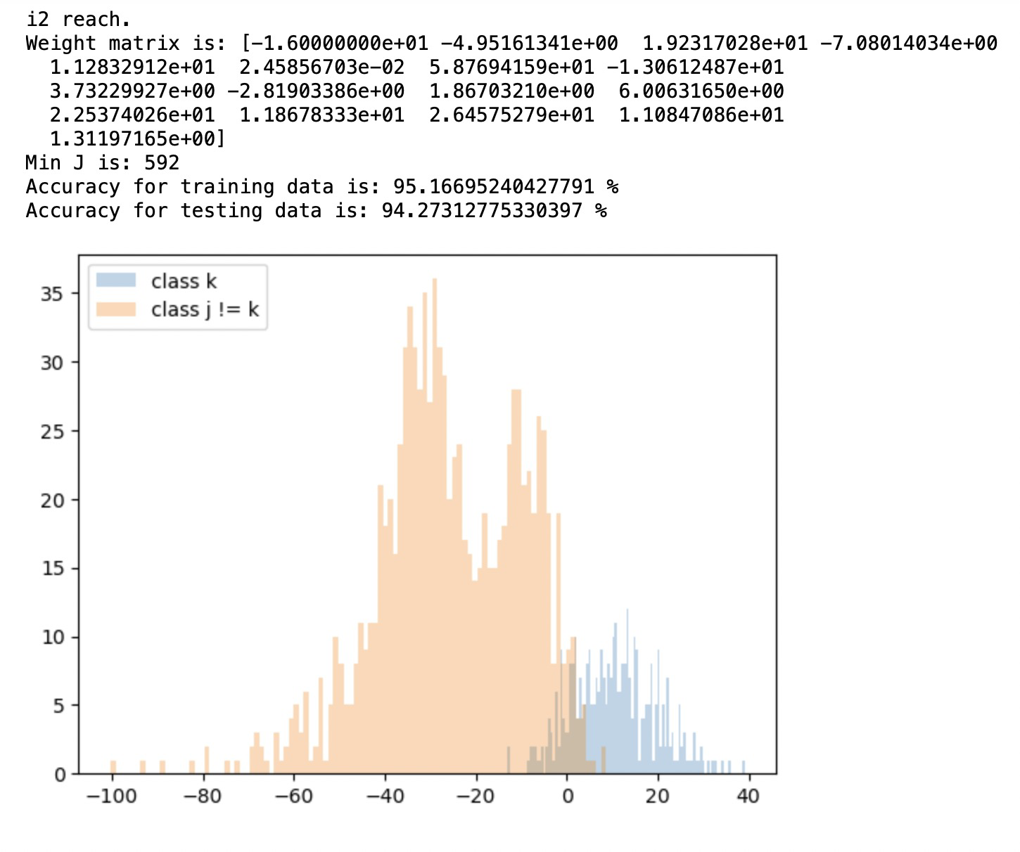

Class 5:

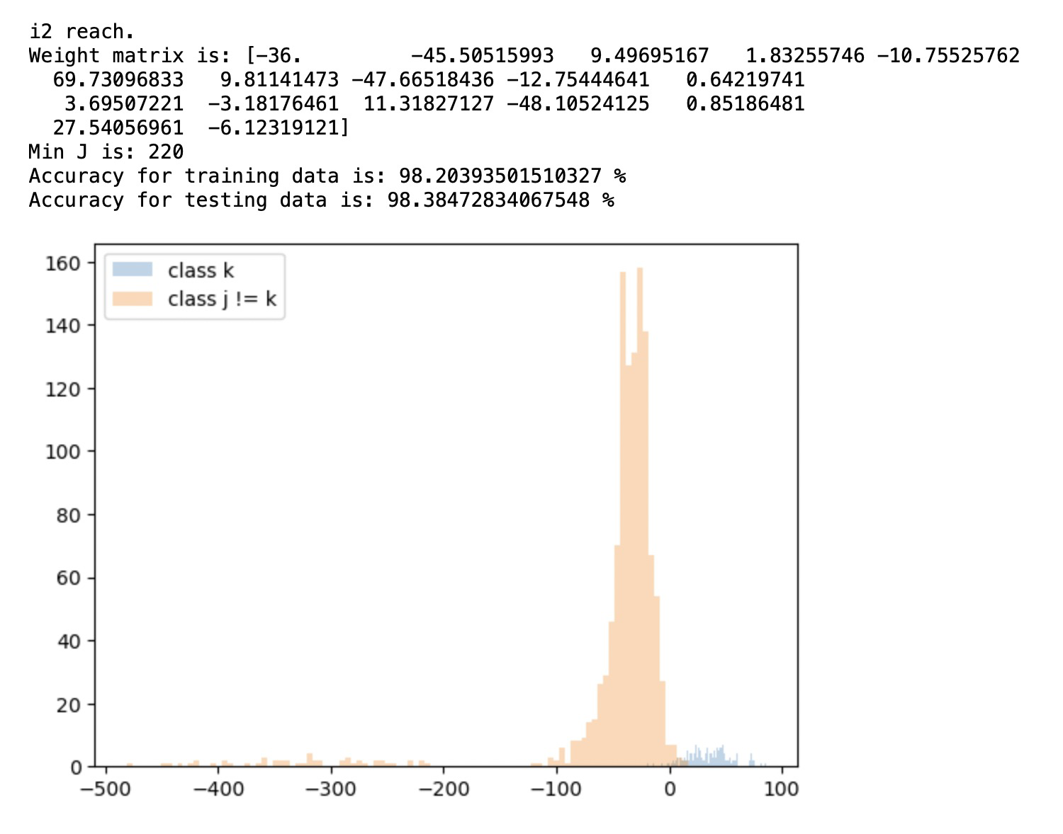

Class 6:

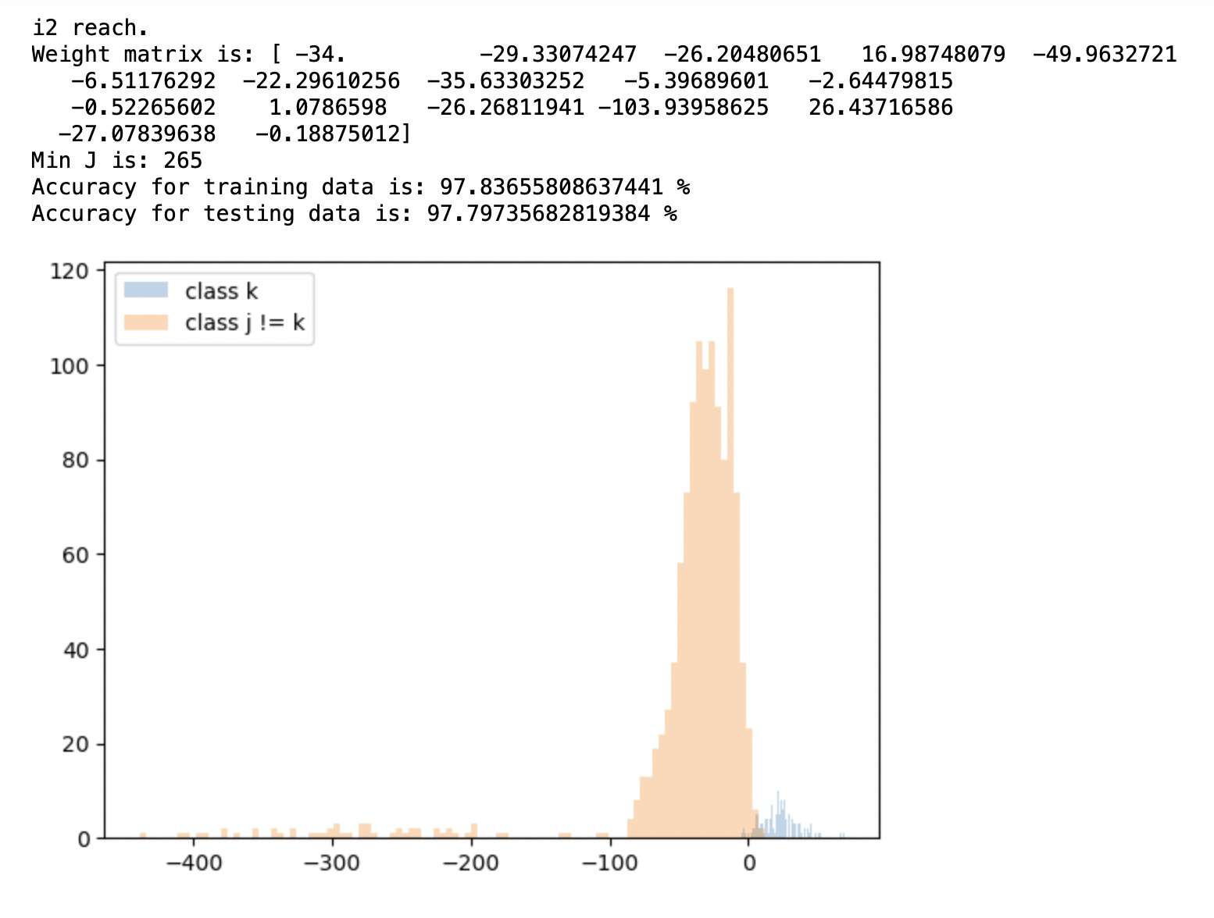

Class 7:

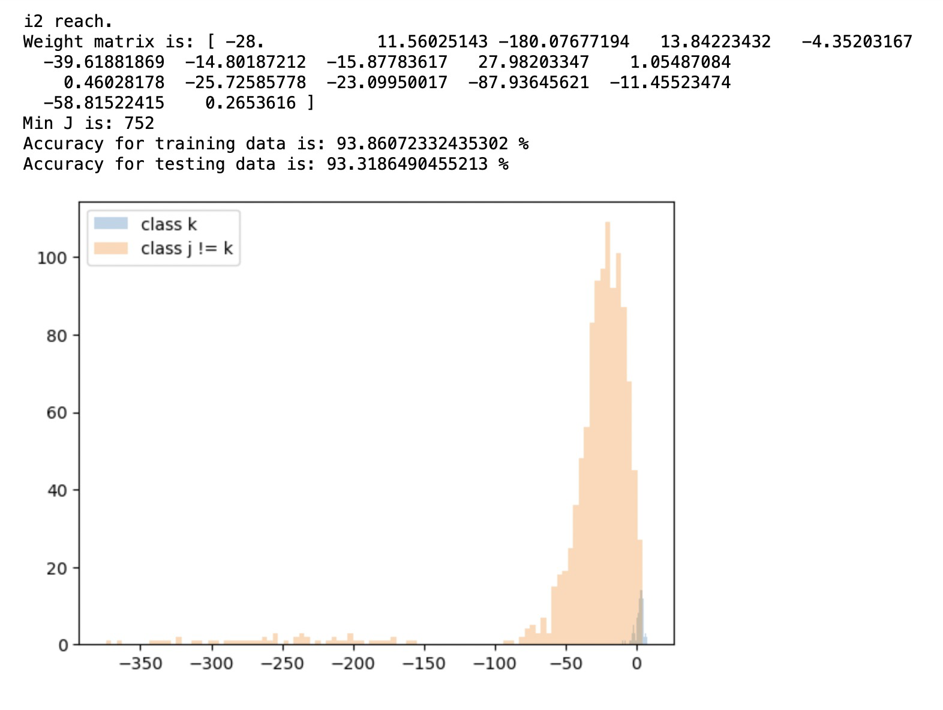

(b) Rule 1:

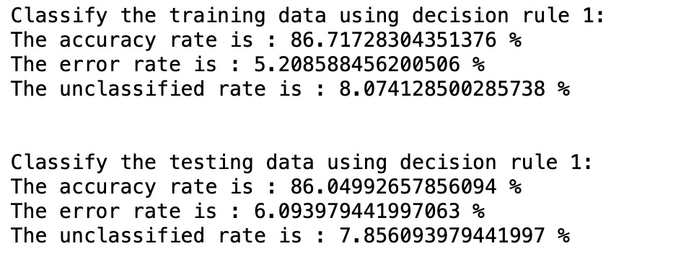

(c) Rule 2:

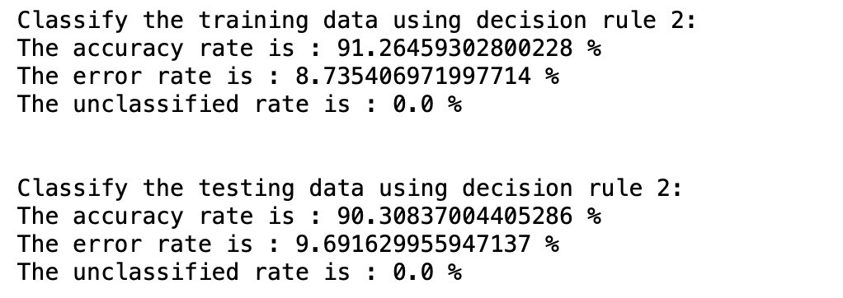

(d) Rule 3:

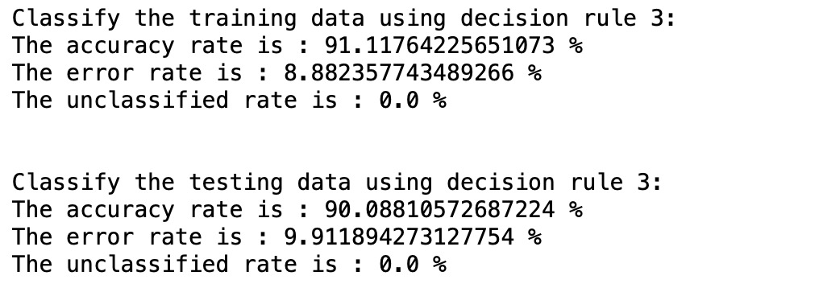

(e) Compare the results of (b)-(d)

Obviously, rule 2 and rule 3 perform better than rule 1 according to the accuracy rate. But the error rate of rule 1 is much smaller than the other one. But there exist an indeterminate region when using rule 1 so there is unclassified data in rule 1’s result as the other one has no indeterminate region.

3.(a) Yes.

g_k(x) / norm||w_k|| is the signed distance form hyperplane H to point x. In the indeterminate region, which means all the g_k(x) < 0, all the distance from H to the x should be negative. Therefore, the maximum of g_k(x) / norm||w_k|| is the minimum abs( g_k(x) / norm||w_k|| ), which means this class k’s decision boundary is the closest to this point x. Therefore, k = argmax( g_k(x) / norm||w_k|| ) which is the closest class. To conclude, this will assign x_n to the same class whose decision region closest to x_n.

(b)Yes.

We can separate the feature region into two regions. The first one is the determinate region and the second one is the indeterminate region.

Obviously, in the second indeterminate region, the decision rules from Approach (i) and Approach (ii) are the same. Therefore, to figure this out, we only need to focus on the first determinate region.

According to the Approach (i), to classify x to class k can only be done by g_k(x) > 0 and g_j(x) < 0 ( j != k). Therefore, g_k(x) = max(g(x)) which means k = argmax(g(x)), which is the same as the Approach (ii).

In my opinion, Approach (i) and Approach (ii) are equivalent.

4.(a) Linear classification

Dataset1_train:

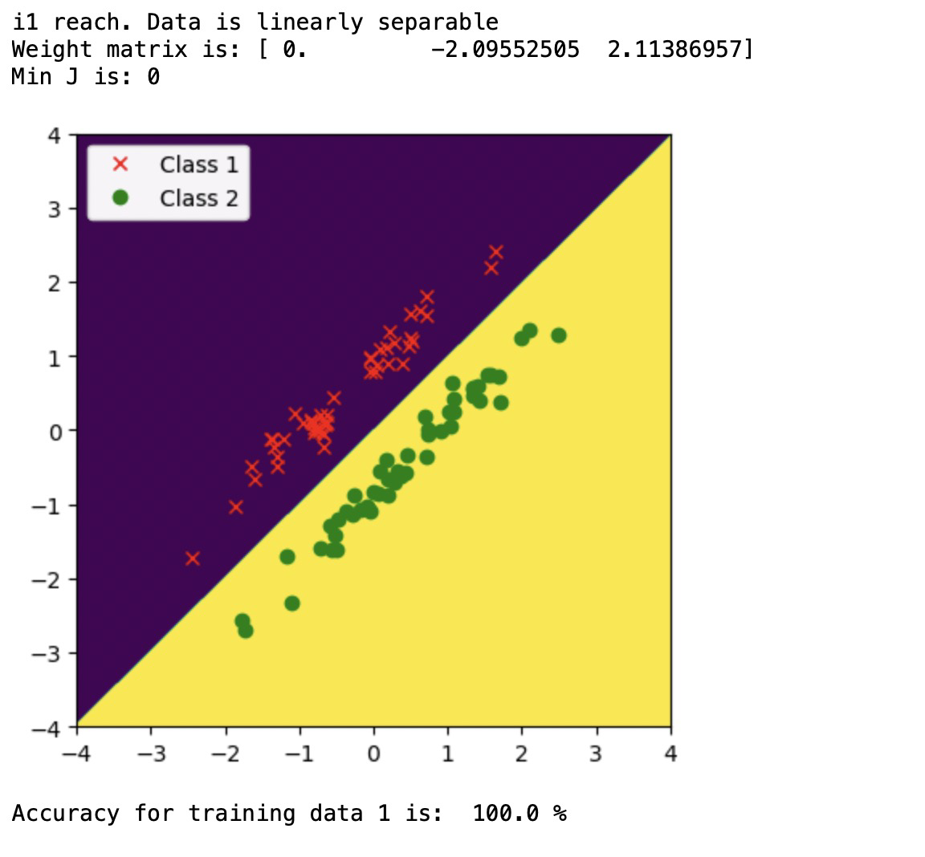

Dataset1_test:

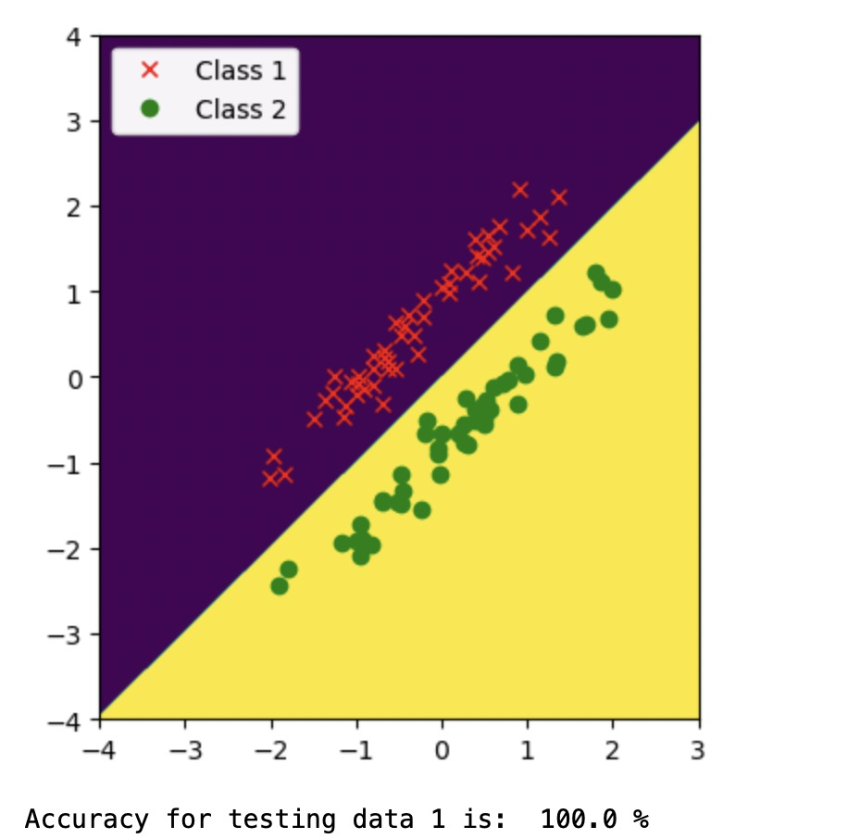

Dataset2_train:

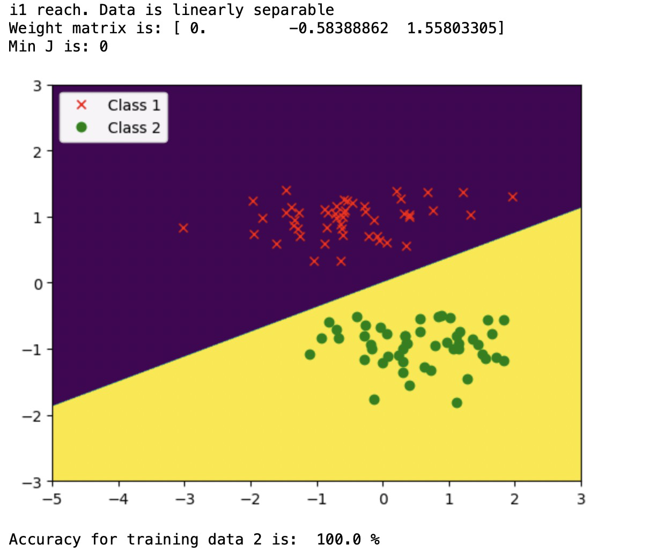

Dataset2_test:

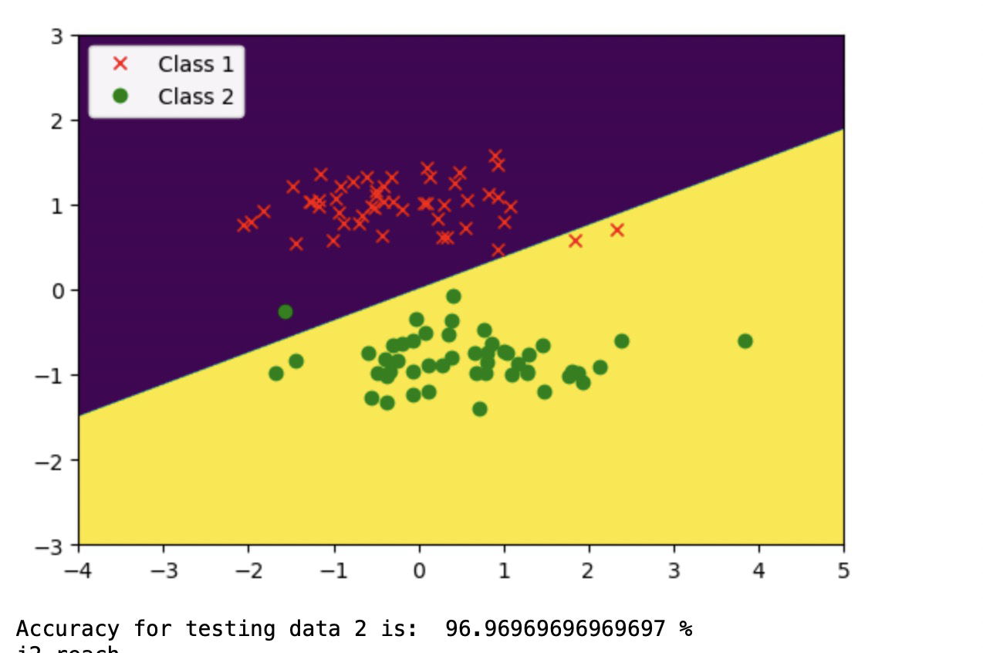

Dataset3_train:

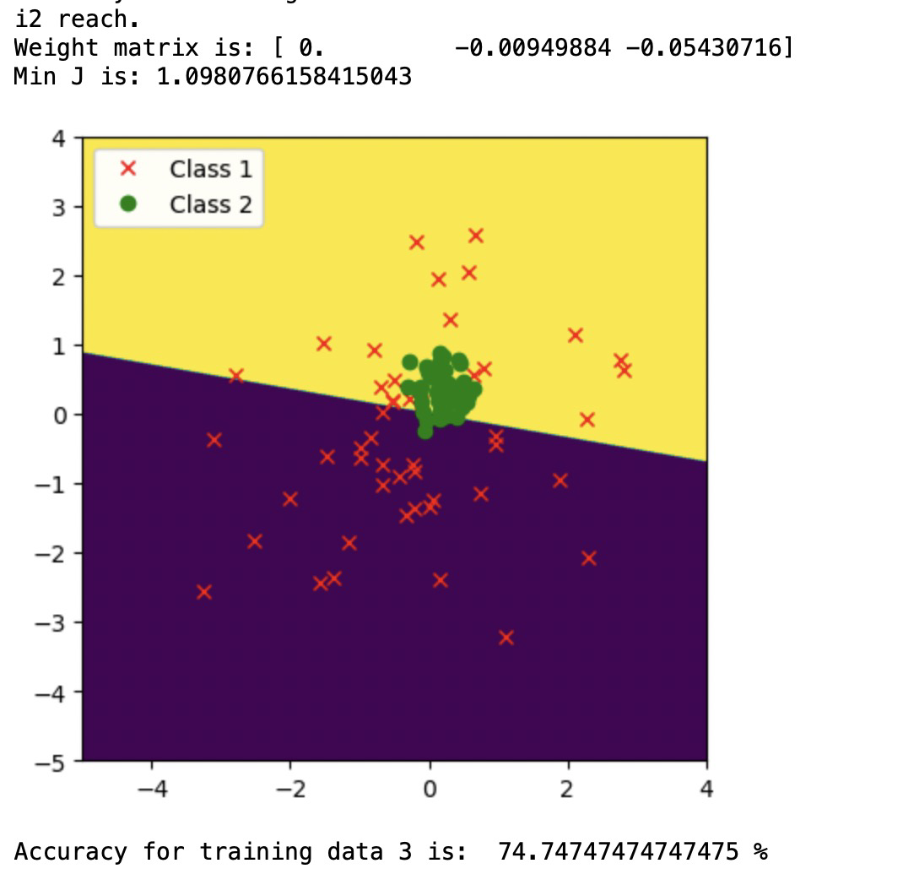

Dataset3_test:

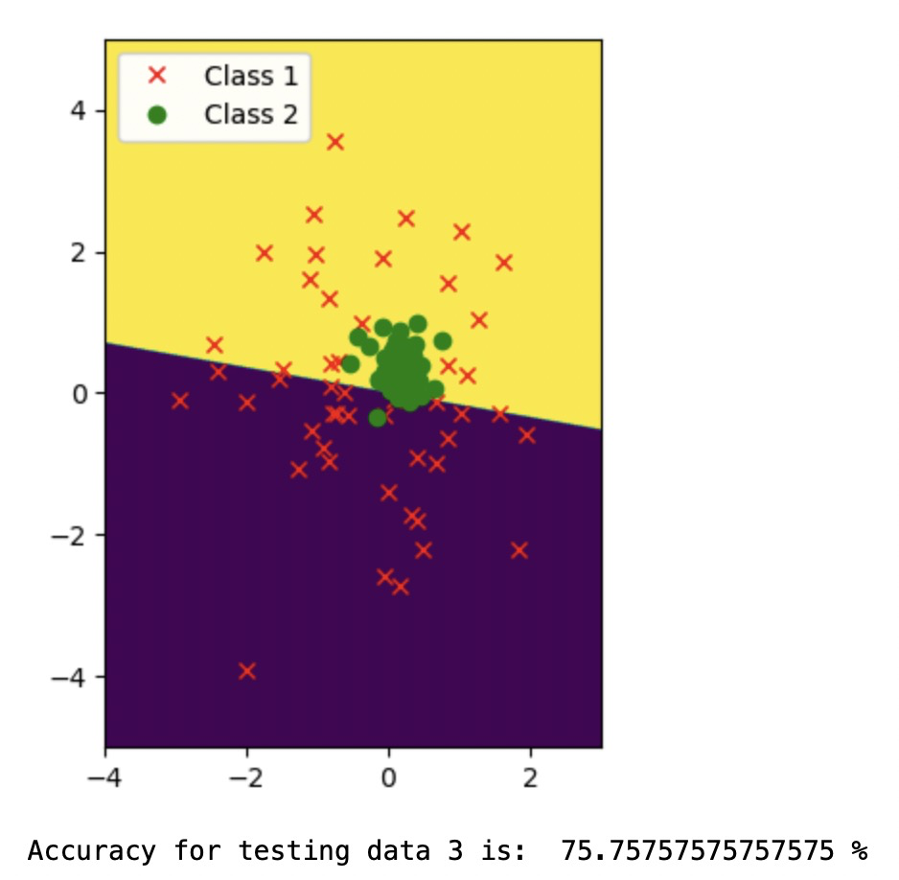

(b) Linear classification 10 runs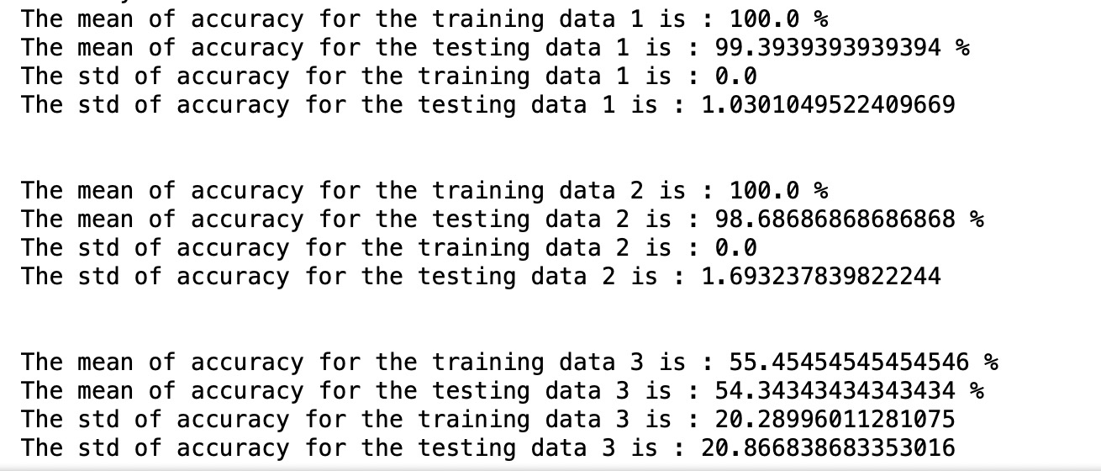

(c) Nonlinear-quadratic classification

Dataset 1:

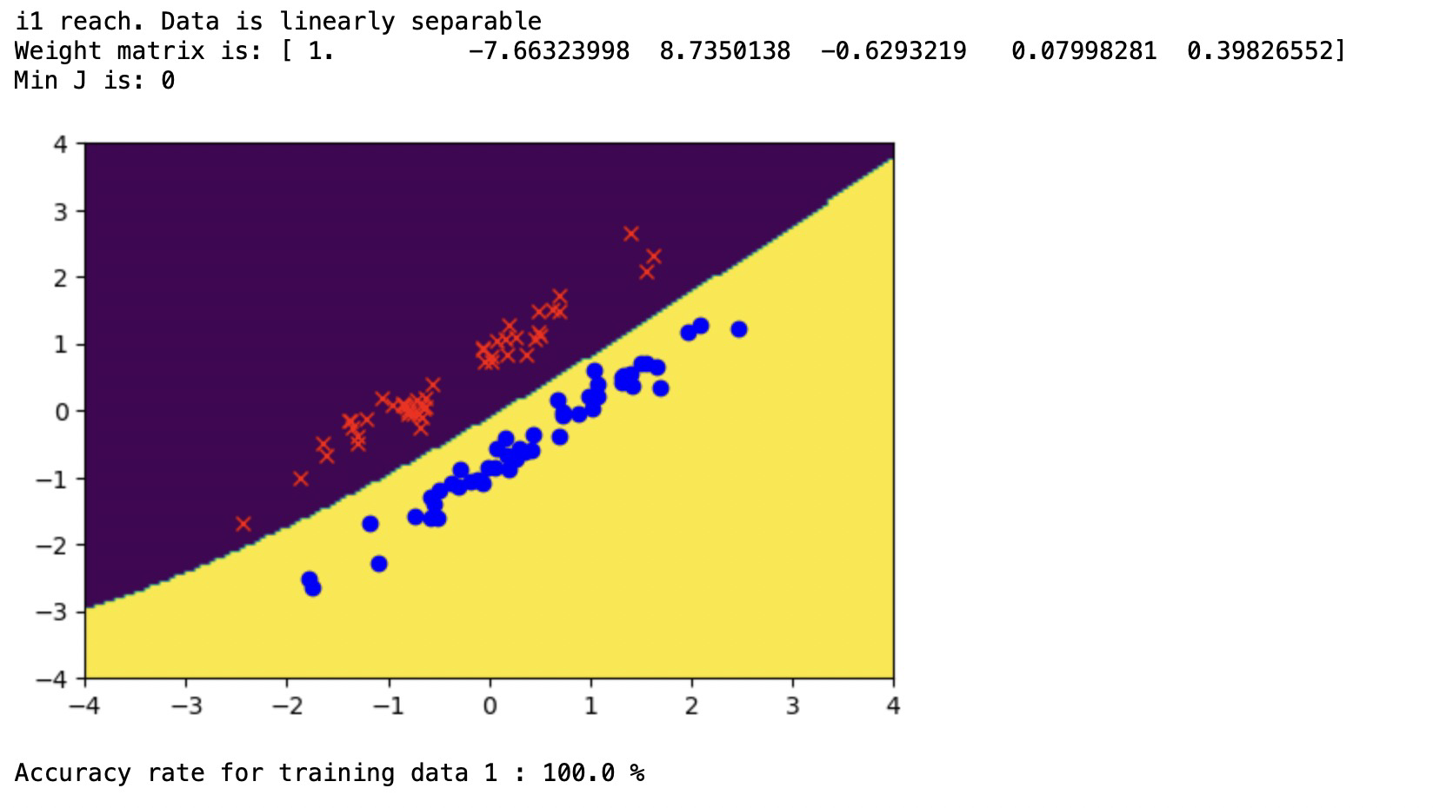

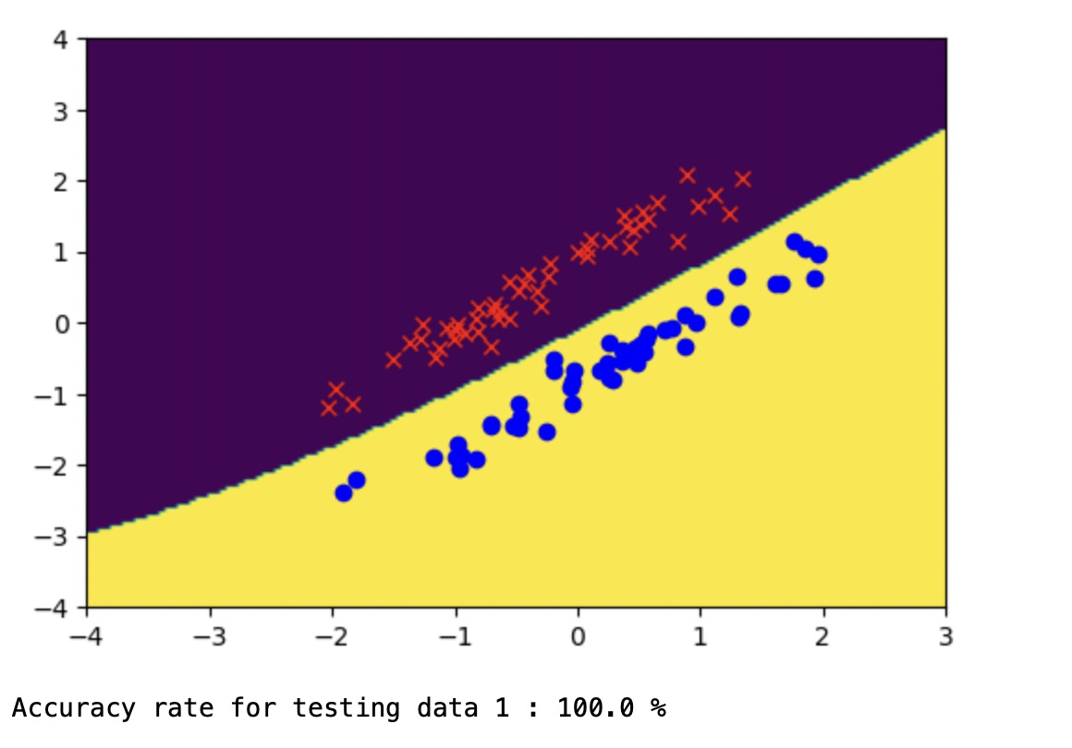

Dataset 2:

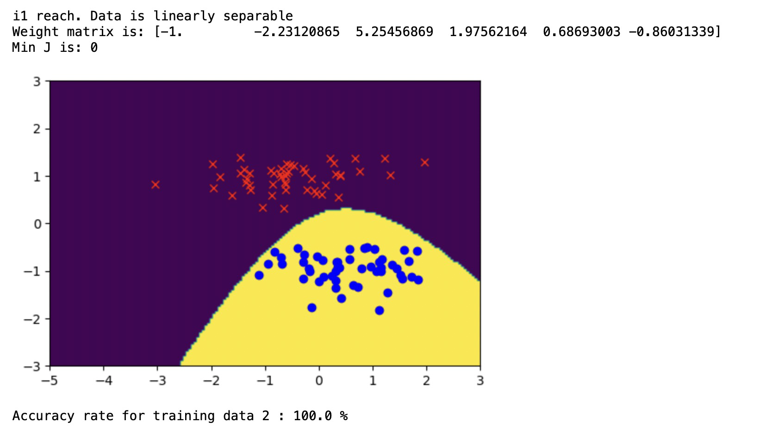

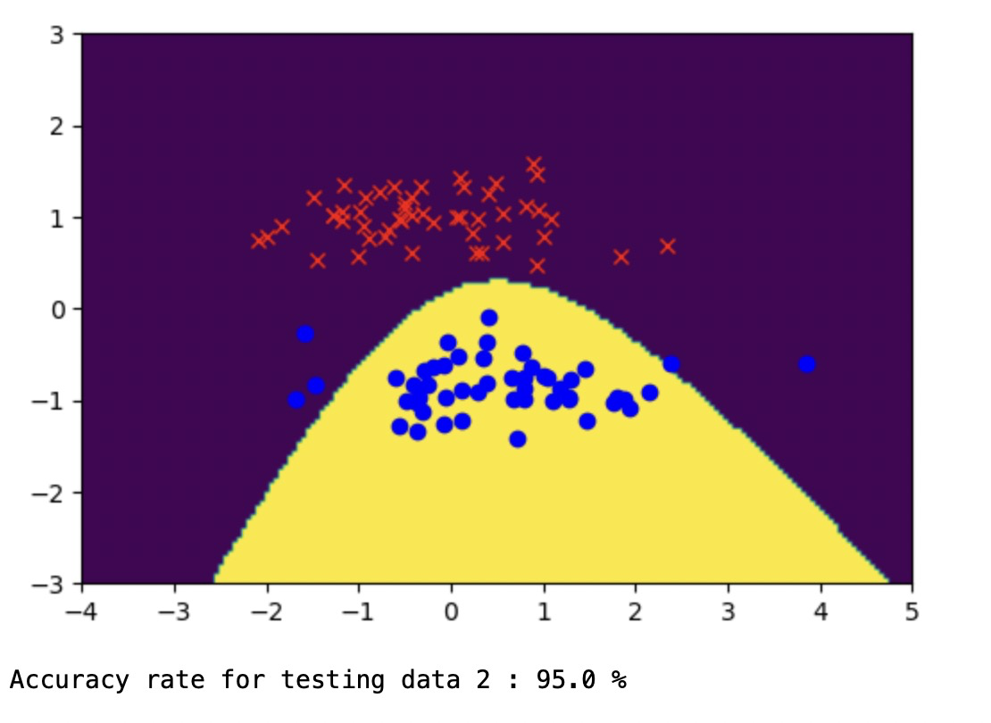

Dataset 3:

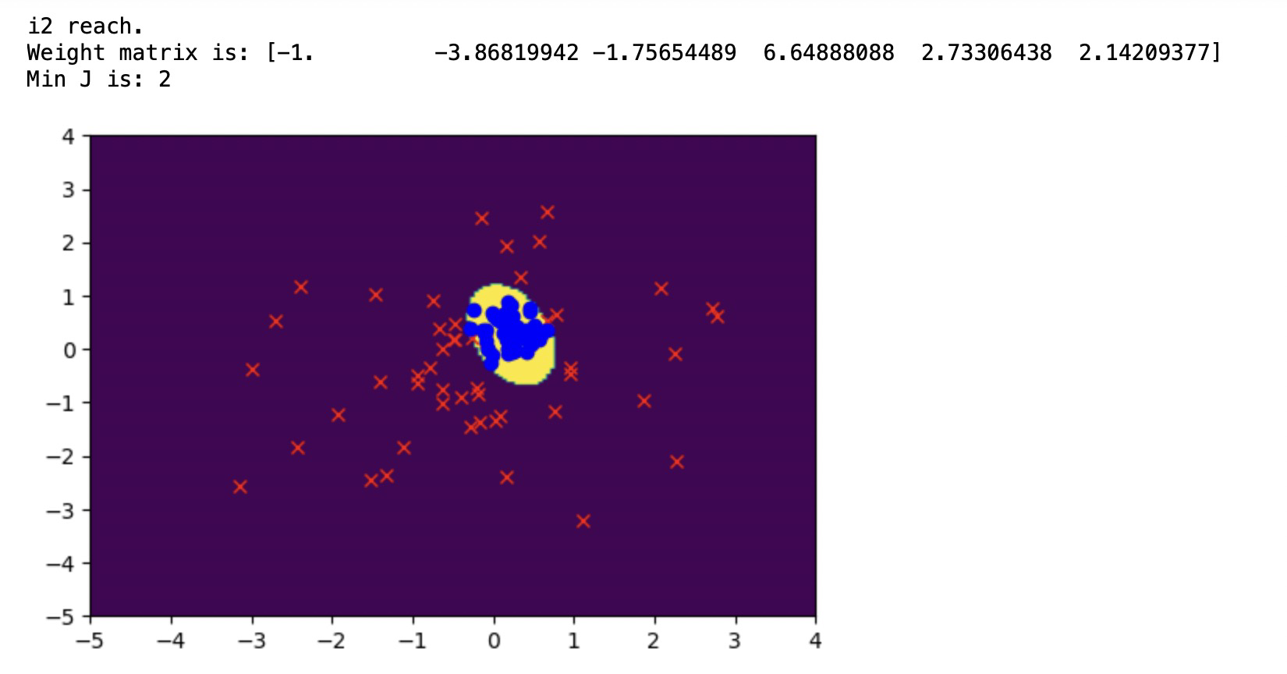

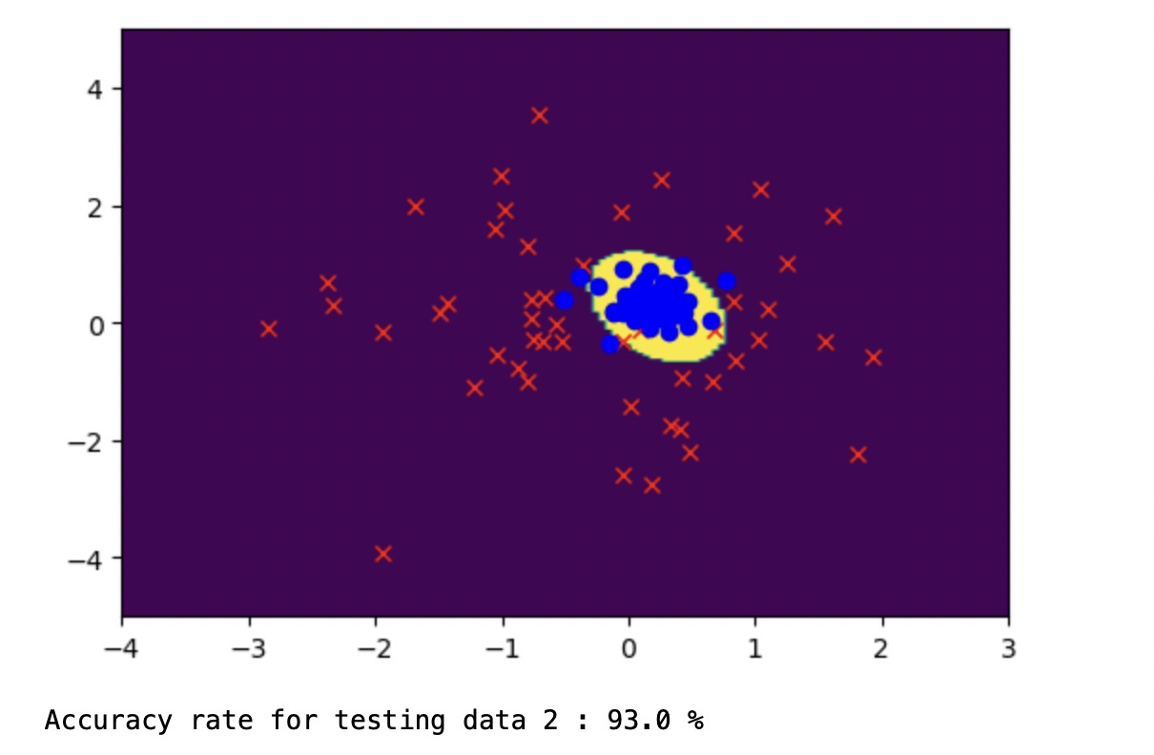

(d) Nonlinear-quadratic classification 10 run

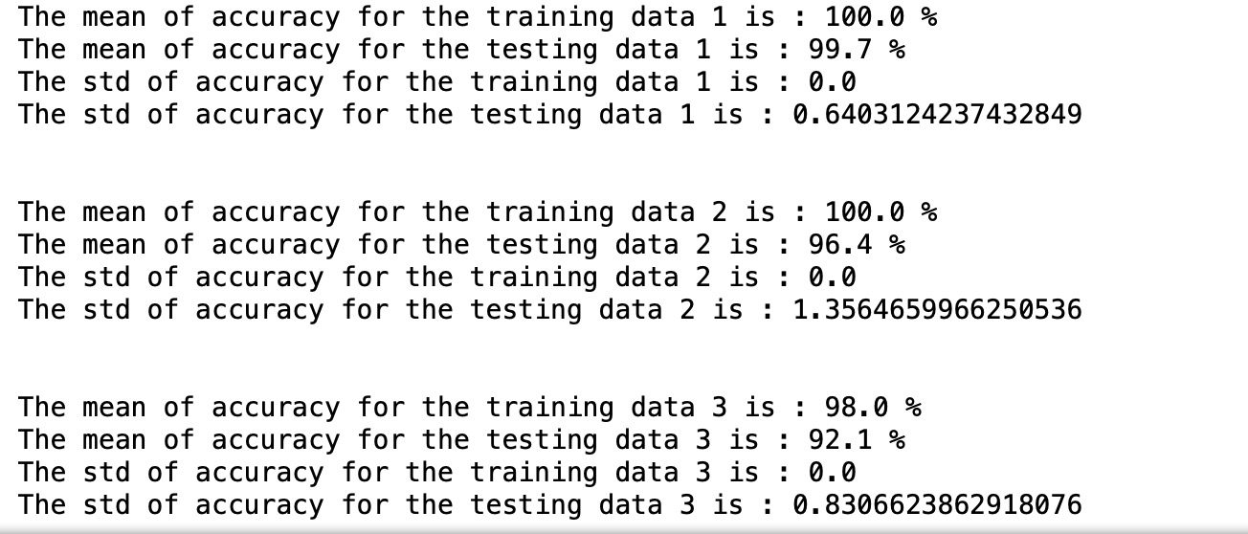

(e) Nonlinear-cubic classification

Dataset 1:

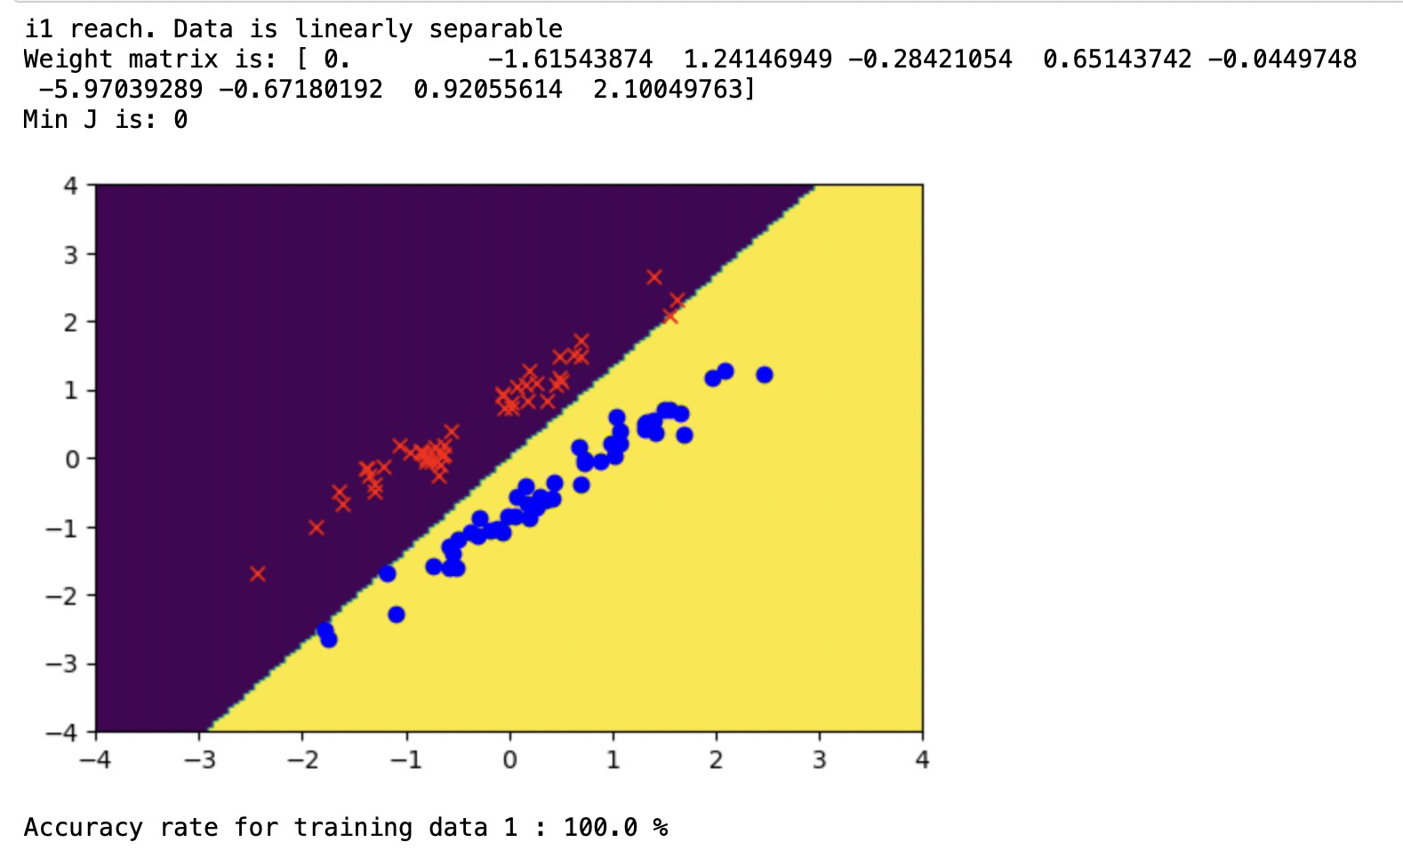

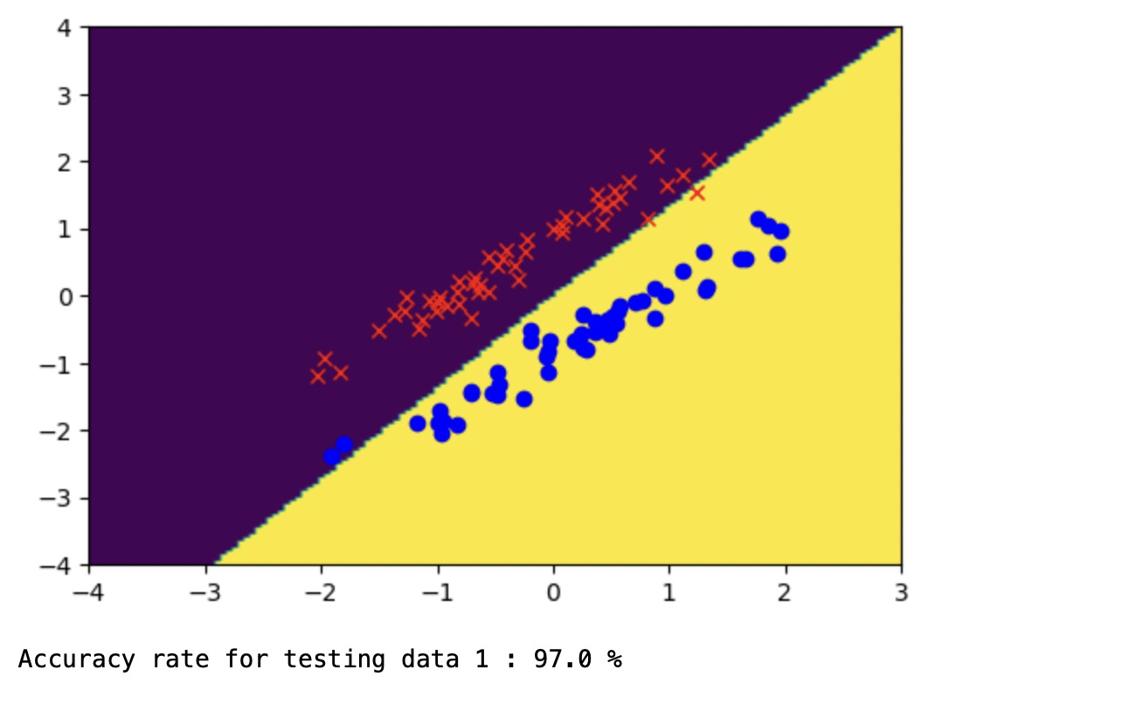

Dataset 2:

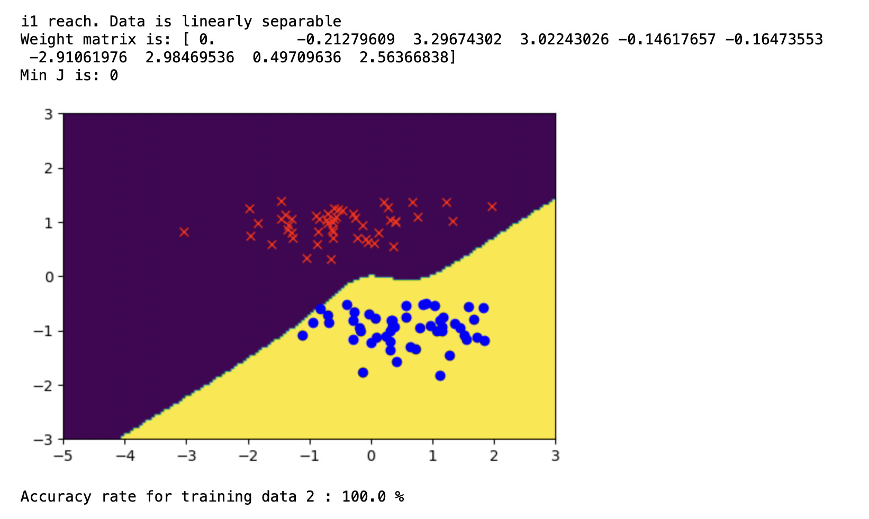

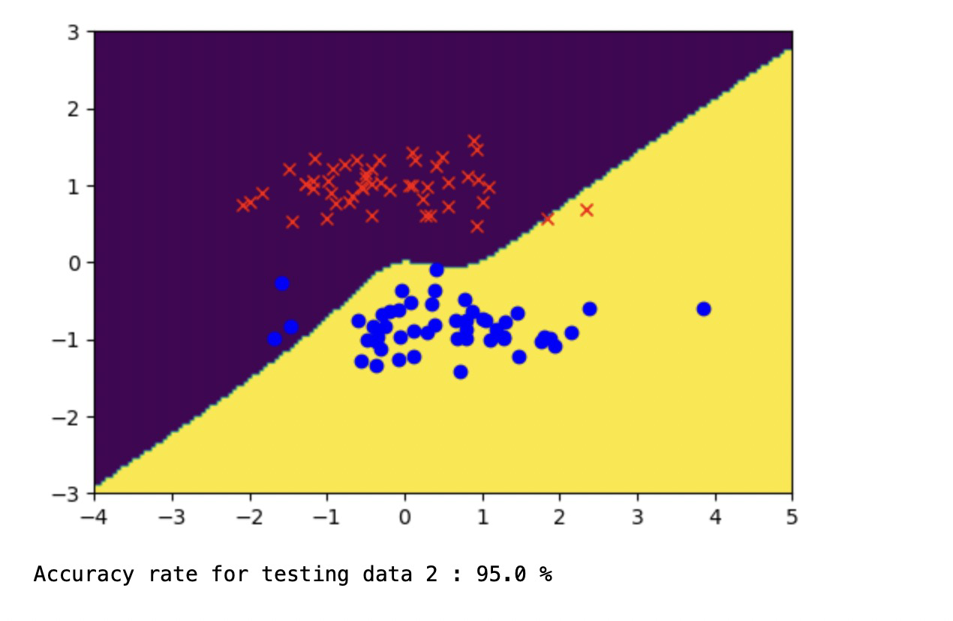

Dataset 3:

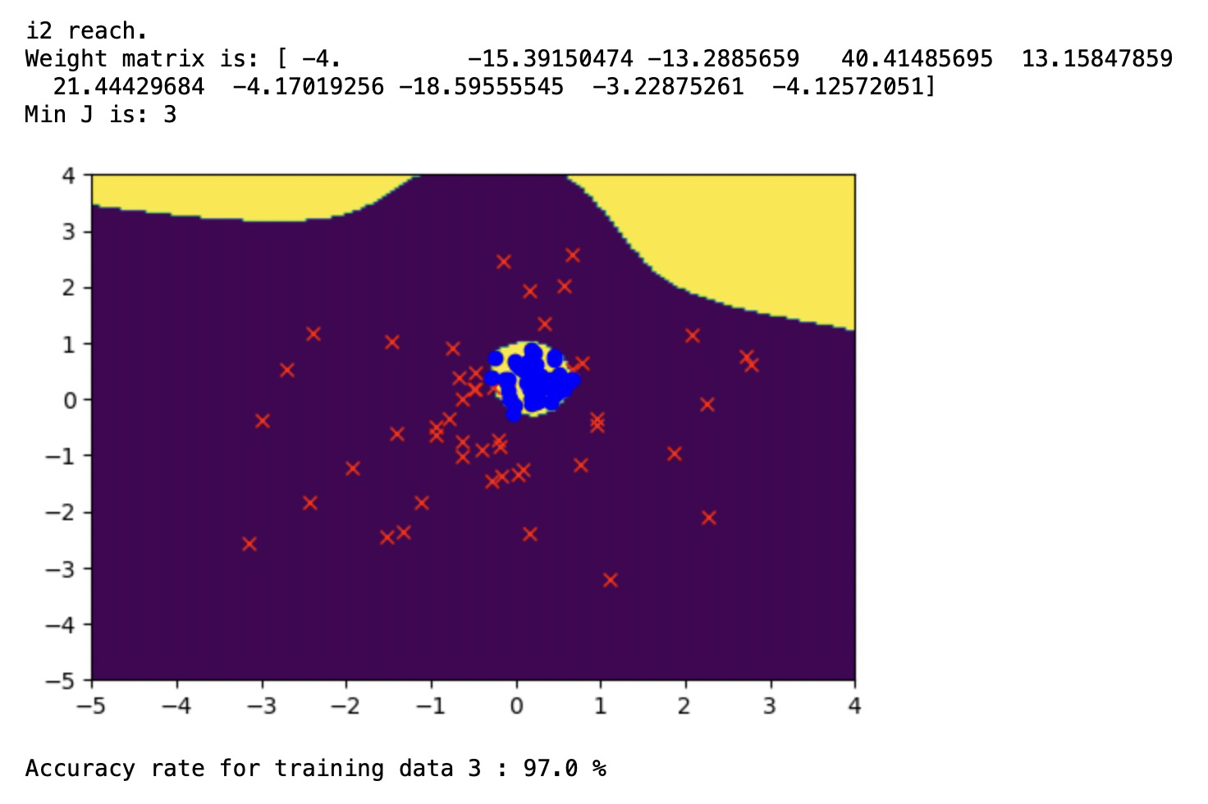

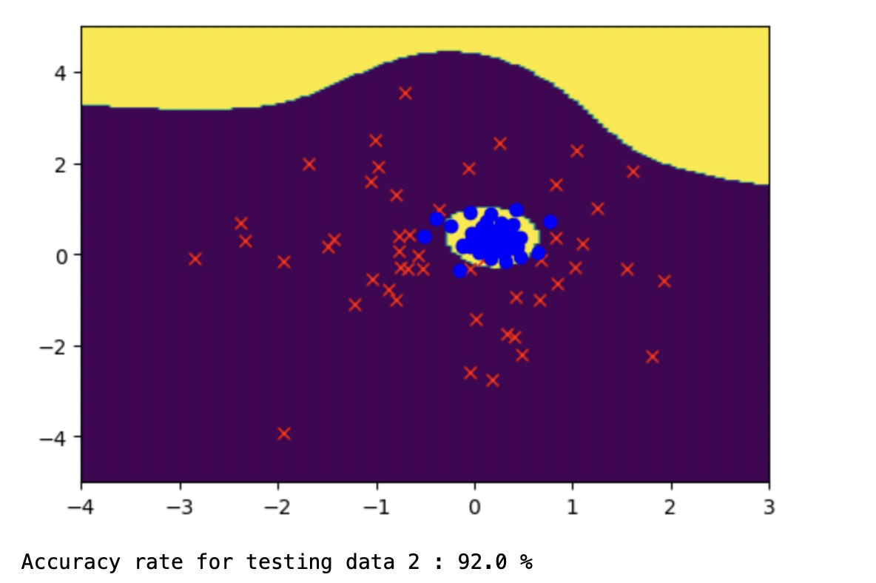

(f) Nonlinear-cubic classification 10 run

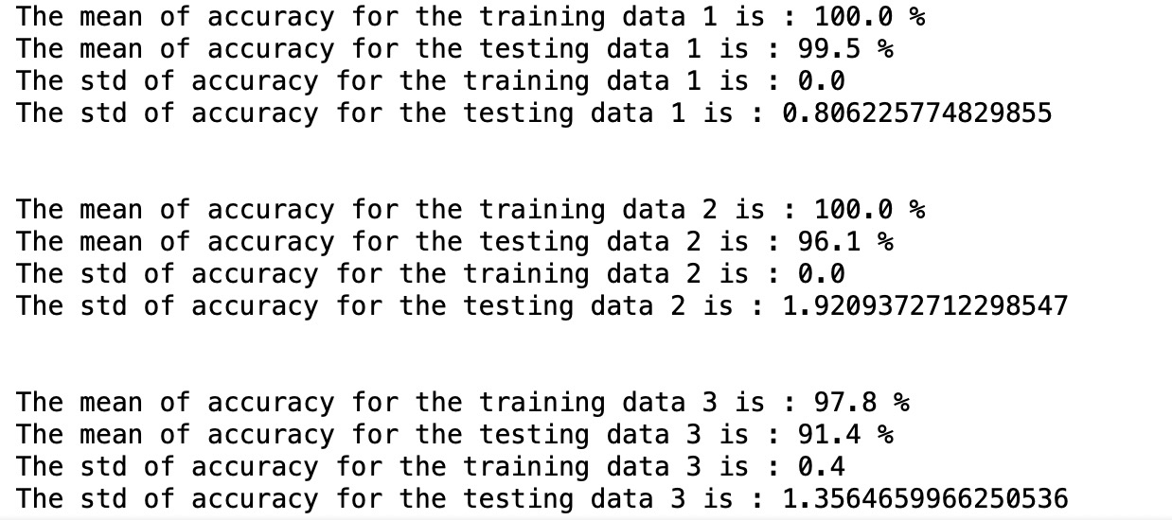

(g) Explain using words and mathematical expressions, how the PlotNonlinear.py routine finds the final decision regions as mapped back into the original feature space.

First, the function defines a grid of points across the feature space. By finding the minimum and maximum values for each feature and expand the grid to ensure the whole feature space is covered.

Xrange and yrange define the range of grid and inc was used to define the step size.

xrange = (min_x, max_x)

yrange = (min_y, max_y)

inc = 0.05

By using the meshgrid() NumPy function, create a grid from np.arange(xrange[0], xrange[1]+inc/100, inc) and np.arange(yrange[0], yrange[1]+inc/100, inc) two vector.

(x, y) = np.meshgrid(np.arange(xrange[0], xrange[1]+inc/100, inc), np.arange(yrange[0], yrange[1]+inc/100, inc))

Define the first feature x1 is our x-axis of the feature space and x2 as our y-axis of the feature space, then we need one row of x1 values of the grid for each point on the y-axis and one column of x2 values of the grid for each point on the x-axis.

The function stack the vectors, to make (x,y) pairs as a bunch of row vectors and get the transformed matrix to find the predict label.

xy = np.hstack( (x.reshape(x.shape[0]*x.shape[1], 1, order='F'), y.reshape(y.shape[0]*y.shape[1], 1, order='F')) )

Then feed this into the model and get a prediction for each point in the grid by using the predictor which defined by ourself.

pred_label = predictor(xy, weight)

What’s more, plot the grid of values as a curve. The function use x.shape that we defined earlier and reshape the pred_label from the model to have the same shape.

decisionmap = pred_label.reshape(image_size, order='F')

Finally, using plt.imshow to plot the decision surface with two different color. And also plot each data points according to their actual label.

(h) Compare your results of (a)-(f) (e.g., compare plots to plots; mean (and std.) accuracies to mean (and std.) accuracies). You can use standard deviations to gauge whether small differences in mean accuracies are statistically significant. Try to explain what you observe.

Comparing plots to plots, we can find that the decision boundary of linear classification is a line with offset while the decision boundary of nonlinear classification is a curve. And comparing the curve of quadratic classification results with cubic classification results, the former curve is like a part of a circle or an oval which is much smoother while the other one has more twists.

Comparing the mean and std. of the accuracies, the linear classification performs best when the data can be linearly separatable but on the other hand, the mean accuracy is low, and the std. is large when the data can’t be linearly separatable. The nonlinear classifications perform much more stable in both situations considering the smaller std. The mean accuracy of both quadratic and cubic are good and differ slightly. The std. of cubic is a little bigger than the quadratic’s which may be caused by the higher degree of the polynomial.